**HISTORY OF COMPUTER**

**Computer** is a machine that capable of esecuting instructions on data computationally.

What differences them is its ability to store its own instructions, whether its memory, processor, or else.

First digital computer might be the **abacus** used by the Chinese 3000-4000 years ago.

Chinese 3000 – 4000 years ago

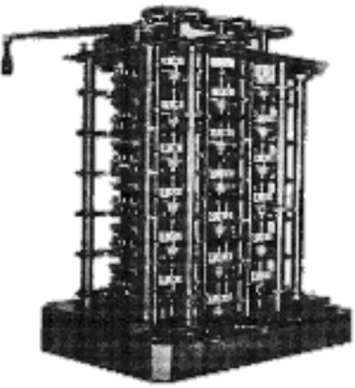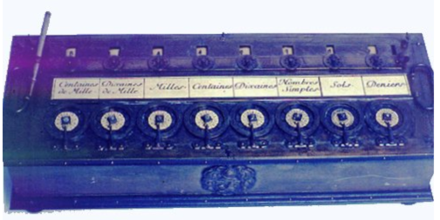

**Hewlett-Packard company known as HP** is founded by David Packard and Bill Hewlett in a Palo Alto, California, garage, according to the Computer History. Museum.

Alan Turing presents the notion of a **universal machine, later called the Turing machine**, capable of computing anything that is computable.

1939

1936

Herman Hollerith designs a **punch card system** to calculate the 1880 census, accomplishing the task in just three years and saving the government $5 million. He establishes a company that would ultimately become IBM. (International Business Machines)

1890

English mathematician Charles Babbage conceives **of a steam-driven calculating machine** that would be able to compute tables of numbers.

1822

1801

**Pascal’s adding machine** of 1642 was a better first example of an analog computer, but like the abacus, it was only a calculator.

In France, Joseph Marie Jacquard invents **a loom that uses punched wooden cards** to automatically weave fabric designs. Early computers would use similar punch cards.

1642

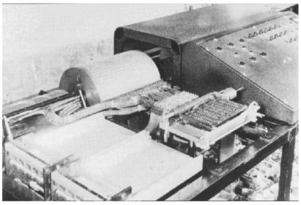

Atanasoff and his graduate student, Clifford Berry, design **a computer that can solve 29 equations** simultaneously. This marks the first time a computer is able to store information on its main memory.

1942

1977

A number **of personal computers hit the market, including Scelbi & Mark-8 Altair**, IBM 5100, Radio Shack's TRS-80 — affectionately known as the "Trash 80" — and the Commodore PET.

1974-1977

1964

Douglas Engelbart shows a prototype **of the modern computer, with a mouse and a graphical user interface (GUI)**. This marks the evolution of the computer from a specialized machine for scientists and mathematicians to technology that is more accessible to the general public.

1958

Jack Kilby and Robert Noyce unveil the integrated circuit, known as the **computer chip.**

The **FORTRAN programming language**, an acronym for FORmula TRANslation, is developed by a team of programmers at IBM led by John Backus, according to the University of Michigan.

1954

Grace Hopper develops the first computer language, which eventually becomes known as **COBOL.**

1953

William Shockley, John Bardeen and Walter Brattain of Bell Laboratories invent **the transistor**. They discovered how to make an electric switch with solid materials and no need for a vacuum.

Mauchly and Presper leave the University of Pennsylvania and receive funding from the Census Bureau to build the UNIVAC, the **first commercial computer** for business and government applications.

IBM created the Mark I computer, an **electromechanical computer**.

1944

1947

1946

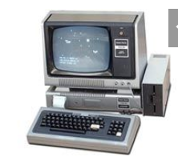

**Radio Shack's** initial production run of the TRS-80 was just 3,000.

The first **IBM personal computer, code-named "Acorn**," is introduced. It uses Microsoft's MS-DOS operating system. It has an Intel chip, two floppy disks and an optional color monitor. Sears & Roebuck and Computerland sell the machines, marking the first time a computer is available through outside distributors. It also popularizes the term PC.

1981

The Defense Advanced Research Projects Agency (DARPA) is developing a new **"Molecular Informatics" program that uses molecules as computers**. It gives many ways to encode and process data beyond the 0s and 1s of current logic-based.

2017

First **programmable quantum computer** was created. It was an idea from Shantanu Debnath, a quantum physics and optical engineer at the University of Maryland, College Park.

2016

Microsoft launches **Windows 7,** which offers the ability to pin applications to the taskbar and advances in touch and handwriting recognition, among other features.

The iPhone brings many **computer functions to the smartphone**.

2007

Apple introduces **the MacBook Pro**, its first Intel-based, dual-core mobile computer, as well as an Intel-based **iMac.** Nintendo's Wii game console hits the market.

The **first 64-bit processor, AMD's Athlon 64**, becomes available to the consumer market.

Compaq brings the **Deskpro 386** to market. Its 32-bit architecture provides as speed comparable to mainframes.

1986

**Apple's Lisa is the first personal computer with a GUI**. It also features a drop-down menu and icons. It flops but eventually evolves into the Macintosh. The Gavilan SC is the first portable computer with the familiar flip form factor and the first to be marketed as a "laptop."

2009

2006

1983

2003